ECSNet: A Real-time Image Segmentation Algorithm for Pavement Crack Detection

Tianjie Zhang, Donglei Wang, Yang Lu

Abstract:

A real-time pavement crack detection is a critical task for insuring safe road. The recent detection models are focused on the detection accuracy without paying attention to the efficiency while it is an important factor in a real-time task. In this work, we present an efficient model called efficiency crack segmentation neural network (ECSNet) for a real-time pavement cracks detection and segmentation tasks. An ECS-block which is constructed by a combination of $1×1$Conv2D, $3×3$Conv2D and $1×1$Conv2D is introduced for crack information extraction and model parameter reduction. The parallel max pooling and convolutional operation are introduced to speed up the downsizing and filtering process. We present experiments on latency and accuracy tradeoffs on the DeepCrack dataset. Our proposed ECSNet shows a strong performance both in accuracy and efficiency compared to other state-of-the-art models including DeepLabV3, FCN, LRASPP, Enet and DeepCrack-base.

Keyword:

Pavement crack detection; real-time task; image segmentation; deep learning

1. Introduction
Crack is a common defect of pavement which does great harm to the vehicle [1]. Traditionally, the cracks are counting and measuring by engineers, but it is time-consuming and work-intensive. Deep learning becomes the most interesting and advanced method to detect pavement cracks. The general trend of deep learning-based models is to include deeper layers and make more complicated structures in order to achieve high accuracy. For example, Xinzi Sun[2] adopted and enhanced a DeepLabV3 model by attention module which can assign weights between the high-level and low-level feature maps, and it achieved a higher IoU on the DeepCrack, Crack500 and FMA datasets. Zhong Qu et al. [3] proposed a deep learning-based network with hierarchical feature fusion and connected attention architecture to enhance the feature extraction and eventually increase the accuracy of the proposed method (got a F1 score of 0.86). Tingyang Chen [4] proposed an encoder-decoder structural model based on a modified SegNet and got a mAP of 83% which was higher than FCN-8s and MRCNN on a self-collected dataset.
Some researches even merge the visual images with other kind source data to improve the accuracy of their model. For example, Fangyu Liu et al. [5] fusing the visual image and thermal image together to increase the accuracy of classifying asphalt pavement crack severity.
Previous works are mainly focused on enhancing the accuracy of models by constructing complicated structures or combine multi-source data. However, these advances are not necessarily making networks more efficient with respect to size and speed [6]. In the pavement crack detection, the segmentation tasks need to be carried out in a timely fashion on a computationally limited platform. Thus, the high-accuracy models are hard to perform well in the real-life application. There are rising interests and needs in developing small and efficient neural networks for the intelligent transportation system.
Jie Pang [7] proposed a Deep Crack Segmentation Network (DcsNet) by incorporating two feature extraction branches to achieve the balance between speed and accuracy. It reaches an IoU of 58.5 and an FPS of 67.5 on Crack500. Wenjun Wang [1] proposed a lightweight road crack segmentation model based on a bilateral segmentation network. The model was trained and tested on Crack500. It got a IoU of 73.79 and FPS of 31.3. The Enet proposed by Adam [8] changed the previous encoder-decoder symmetrical structure, reduced the convolution operation in the decoder, and enhanced the processing speed tremendously. It introduced the $1×1$ projection to reduce the dimensionality and parameters of the model without reducing the accuracy and achieved a higher mIoU (mean Intersection over Union) than SegNet. A model can make a good trade-off between the accuracy and efficiency can be helpful to handle the real-time tasks which is very significant to the decision-makers and engineers.
In order to speed up the detection task without dropping the accuracy, we proposed an Efficient Crack Segmentation Network (ECSNet) to keep a trade-off between accuracy and efficiency of pavement crack detection tasks. An ECS-block which is constructed by a combination of $1×1$Conv2D, $3×3$Conv2D and $1×1$Conv2D is introduced for crack information extraction and model parameter reduction. The parallel max pooling and convolutional operation are introduced to speed up the downsizing and filtering process. The proposed ECSNet is tested on the DeepCrack dataset and is compared with other state-of-the-art models including DeepLabV3, FCN, LRASPP, Enet and DeepCrack-base. The result shows that our model performs a trade-off between the accuracy and efficiency which means it can be utilized into the real-time pavement crack detection and measurement tasks.
The paper is organized in the following way: The details of the proposed ECSNet are described in Section 2; Section 3 demonstrates experiments design and analyzes experimental results. Section 4 is the conclusion.

2. Method

2.1 ECSNet

Efficiency Crack Segmentation Neural Network (ECSNet) is proposed in this work to improve the efficiency of the pavement crack detection tasks without decreasing the accuracy of the segmentation result. The architecture of the proposed ECSNet is shown in Figure 1.

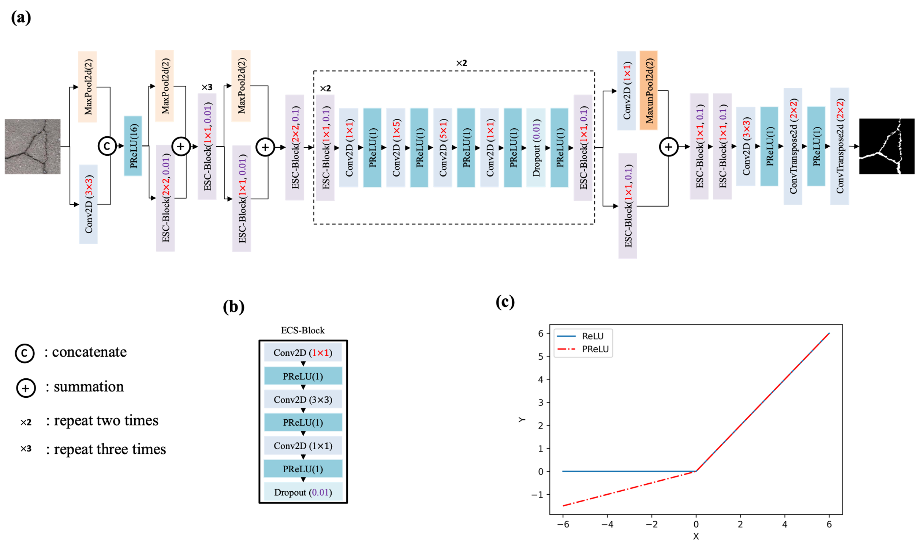

Figure 1. The architecture of the proposed ECSNet and its components: (a) The architecture of the proposed ECSNet; (b) An ECS-Block is consisting of three convolutional layers: $1×1$Conv2D, $3×3$Conv2D and $1×1$Conv2D. The PReLU is used as an activation function in the ECS-Block; (c) A comparison between ReLU and PReLU.

The proposed ECSNet contains 58 convolutional layers in total. Some techniques used in the network to avoid redundant and speed up training speed are described below:

(1) Each convolution layer in ECSNet is followed by a Batch Normalization layer which can standardize the parameters and speed up the training procedure.
(2) Instead of using large kernels, we mainly use small kernel convolutional layers like $1×1$Conv2D in the architecture to downsize the parameters. We use the ECS-Block, a combination of $1×1$Conv2D, $3×3$Conv2D and $1×1$Conv2D, which can be regarded as decomposing a large-kernel convolutional layer into a series of smaller operations. It can obviously reduce the number of parameters and make the process less redundant compared to using large convolutional operations. A dropout layer is applied at the end of the block to regularize the result from the convolutional layer to avoid overfitting problems. There are two parameters for the BCS-Block. The first parameter stands for the kernel size of the first convolutional layer in the block. The second parameter stands for the p value in the Dropout layer.
(3) The ECSNet does not use a normal encoder-decoder symmetrical structure. In order to speed up the prediction, the convolutional operation is reduced in the decoder part which enhances the processing speed tremendously.
(4) Each $n×n$ convolutional layers can be decomposed into two smaller ones: one with a $1×n$ kernel and one with a $n×1$ kernel. This idea has been worked and proved in Adam’s work [8]. The cost of the operation is lowered but the variety of operations increased which can increase the ability of network to learn more various details about the road images.
(5) For a real-time detection job, it is necessary to down sample the input image quickly after inputting the training image. However, an aggressive dimensionality reduction in operation can hinder the spatial information transferring. Thus, we use a convolutional layer with a $3×3$ filter to downsize the input firstly, rather than using a $1×1$ filter directly on the input image to sharply lower its size. After that, a convolutional layer with a $2×2$ kernel size is used to downsize the pavement images again. A kernel size of $2×2$ makes sure that we can take the full input as consideration from a $3×3$ filter and decrease the information loss during the training.
(6) It is common to use a max pooling layer right after a convolutional layer to downsize the image, which would lower the computational efficiency. In this work, we perform the max pooling operation in parallel with a convolutional layer, and concatenate them together. It can merge the feature maps generated by pooling and convolution operations which will also speed up the inference time without losing information.
(7) The PReLU is used as the nonlinear layer in the network, especially in the decoder part. The equation of PReLU is shown below.

$$PReLU\left(x\right)=\left\{\begin{aligned}x,x≥0 \\ Ax,x<0\end{aligned}\right.$$

Where A is a learnable parameter, the initial value of A is 0.25. x means the number of layers to input into the activation function.
As shown in Figure 1(c), the PReLU can give a learnable weight to the small values while they are totally ignored in the ReLU function. The reason to use PReLU rather than ReLU is that the crack in pavement is the relative dark part in the background. Using a PReLU can keep the crack information more accurate when downsizing the images.

2.2 Overall procedure

The overall procedure to evaluate the performance of the ECSNet and comparison with other popular deep learning-based segmentation models are shown in Figure 2.

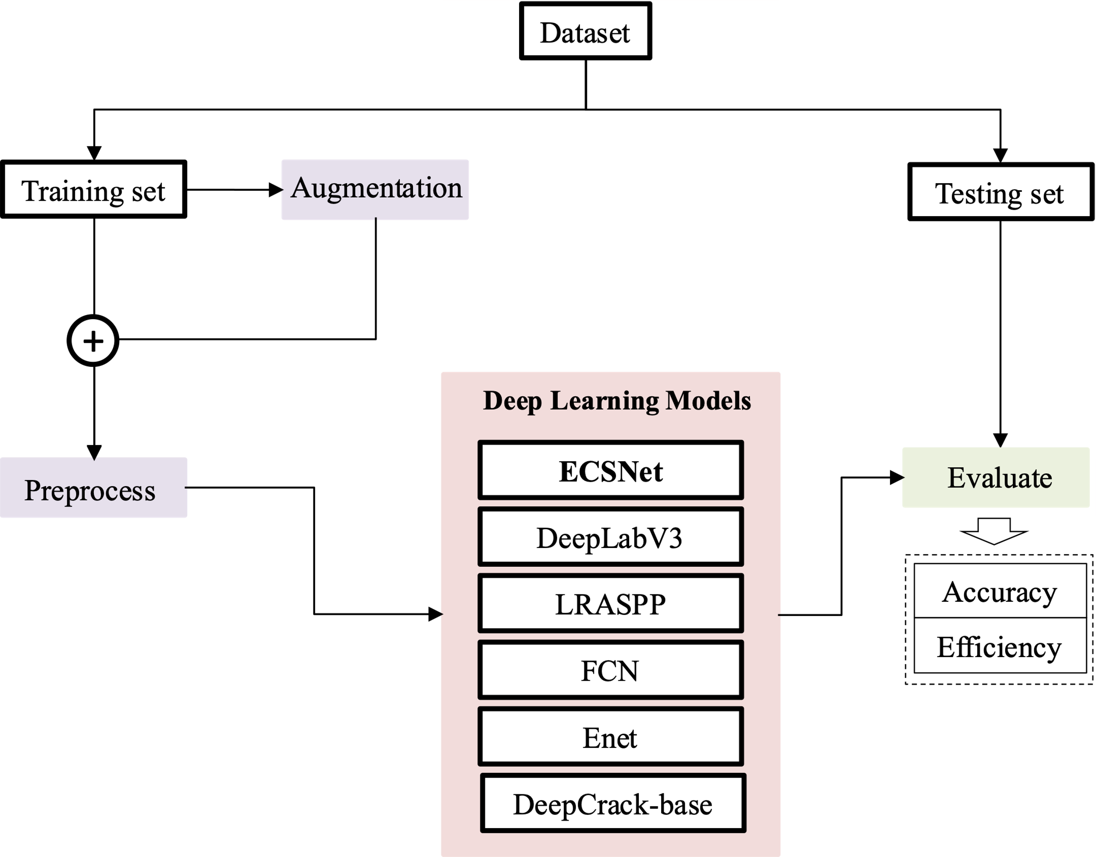

Figure 2. The overall procedure to evaluate the performance of the deep learning neural networks.

A public dataset named DeepCrack is utilized to evaluate the accuracy and efficiency of the deep learning models. The DeepCrack dataset is an open-source dataset published in GitHub (https://github.com/yhlleo/DeepCrack). This dataset consists of 537 RGB crack images with manually annotated segmentations. The image has a resolution of 544 × 384 pixels. In this work, the dataset is randomly divided into training data and testing data at a ratio of 8:2. Then, the images in the training dataset are augmented by data-augmentation methods include random crop, flip and rotate. We perform the same data augmentation operation on the image and the ground truth of the image. These augmented images will be totally new inputs to the neural network. By doing this, the deep learning-based model’s performance would be improved because deep-learning algorithm is deep related on the amount and diversity of datasets it used. After augmentation, the training set is processed by changing the color to gray. In order to reduce the computing power the model used, all the images and their ground truths are resized to $256×256$ pixels before input into the deep learning models. We use less regularization and data augmentation techniques as a small size model has less trouble with overfitting.

Five popular models are also tested on this dataset and compared with our proposed ECSNet. Models includes DeepLabV3, LRASPP, Enet, DeepCrack-base. The details of these models are shown below.
(1) DeepLabV3 [9]: We adapt the ResNet-50 to the original DeepLabV3 structure by applying convolution to extract dense features.
(2) LRASPP: we adapt a Lite R-ASPP Network model with a MobileNetV3-Large backbone [10].
(3) FCN [11]: We adopt FCN-resnet50 by replacing the loss function with BCEWithLogitsLoss for crack detection.
(4) Enet [8]: A deep neural network architecture for real-time semantic segmentation proposed by Adam Paszke. All the hyperparameters are set are default.
(5) DeepCrack-base [12]: This model was developed by the Zou Q who publish the DeepCrack Dataset. The model was trained on the DeepCrack Dataset and all the hyperparameters are set as default.

All models are trained using Root Mean Squared Propagation (RMSProp) [13] with a momentum 0.9 as optimizer to update the network. A learning rate of 1e-4 and a batch size of 16 are utilized during the training. BCEWithLogitsLoss [14] is used as the loss function, which combines a sigmoid layer and the Binary Cross Entropy in one single class. This loss is more numerically stable than using a plain Sigmoid followed by a BCELoss [15]. Totally 300 epochs are trained on each network. The pixels whose output probability value is lower than 0.5 are classified as crack, and others are identified as background.

The data augmentation methods and CNN models are all implemented in Python and computed under the following machine speculations: Windows 10, Intel(R) Core (TM) i9-10900X CPU, NVIDIA RTX A4000 with 16 GB memory, 64GB RAM.

2.3 Evaluation Metrics
The goal of a real-time oriented deep learning model is making a good trade-off between accuracy and efficiency. Thus, in this paper, we have to evaluate and compare both accuracy metrics and efficiency metrics.
For the accuracy part, F1 score (F1) and Intersection over Union (IoU) are utilized to evaluate the semantic segmentation results.

The precision can be calculated using Equation (3). Recall suggests the level of sensitivity for prediction results. Recall can be calculated in Equation (4). F1 is defined based on the harmonic average of Precision and Recall. Thus, F1 score could be a more reasonable metric than Precision or Recall.
$F_{1}=\frac{2PR}{P+R}$ (5)

$P=\frac{TP}{TP+FP}$ (3)

$R=\frac{TP}{TP+FN}$ (4)

Where TP denotes True Positive, FP is False Positive, FN is False Negative, P is precision, R is recall and F1 denotes F1 score.

The IoU measures the overlap between 2 areas. It is used to measure how much the predicted areas overlaps with the ground truth. IoU is calculated according to Equation (6).

$IoU=\sum_{i,j}^{k}{\frac{p_{ii}}{p_{ij}+p_{ji}-p_{ii}}}$ (6)

$MIoU=\frac{1}{k+1}\sum_{i=0}^{k}{\frac{p_{ii}}{\sum_{j=0}^{k}{p_{ij}}+\sum_{j=0}^{k}{p_{ji}-p_{ii}}}}$Where $p_{ij}$ represents the number of pixels belonging to class i but predicted as class j.
The IoU represents how much pixels are correctly predicted and it is a common metric in the image segmentation tasks.

For the efficiency part, the training time of each model is measured to show how much computational resources the model needed in training. The frames per second (FPS) in the testing procedure are used to evaluate the efficiency of the models in predicting. The FPS can be an index for the real-time jobs. A higher FPS means the model can process more images in a unit time, which means it will have a better performance in real-time tasks. The number of parameters is also calculated from each model as it is an important factor in a mobile device. A lightweight model can be easier to be deployed in a smart phone.

3. Results

3.1 Accuracy evaluation

Table 1. shows the precision, recall, F1 score and IoU values from the models tested in this work, including DeepLab v3, LRASPP, FCN, Enet, DeepCrack-base and ECSNet.

Table 1. The Precision, Recall, F1 score and IoU of all the testing models
Models | P(%) |  | R(%) |  | F1(%) |  | IoU(%) |  | Params(M)
Models | Avg | Std | Avg | Std | Avg | Std | Avg | Std | Params(M)
DeepLabv3 | 92.46 | 1.58 | 76.73 | 2.22 | 83.83 | 0.70 | 72.17 | 1.04 | 39.63
LRASPP | 91.62 | 0.31 | 75.35 | 0.44 | 82.69 | 0.23 | 70.50 | 0.34 | 3.22
FCN | 92.11 | 0.60 | 77.70 | 0.41 | 84.29 | 0.43 | 72.86 | 0.65 | 32.95
Enet | 93.07 | 1.23 | 77.12 | 3.11 | 84.31 | 1.50 | 72.90 | 2.26 | 0.36
DeepCrack-base | 91.30 | 0.28 | 81.00 | 1.49 | 85.84 | 0.72 | 75.19 | 1.10 | 30.9
ECSNet | 92.16 | 0.72 | 77.93 | 0.64 | 84.45 | 0.09 | 73.08 | 0.12 | 0.41

It shows that the DeepCrack-base gets the highest F1 score (85.84%) and IoU values (75.19%) among all the model. It is noteworthy to find that the ECSNet gets the second place in F1 score (84.45%) and IoU value (73.08%) with 0.41 M parameters. In other words, the proposed model performs best among the lightweight models (LRASPP, Enet, ECSNet).

Some visualization of detection results of these deep learning-based models is shown in Figure 2 to show their segmentation performance.

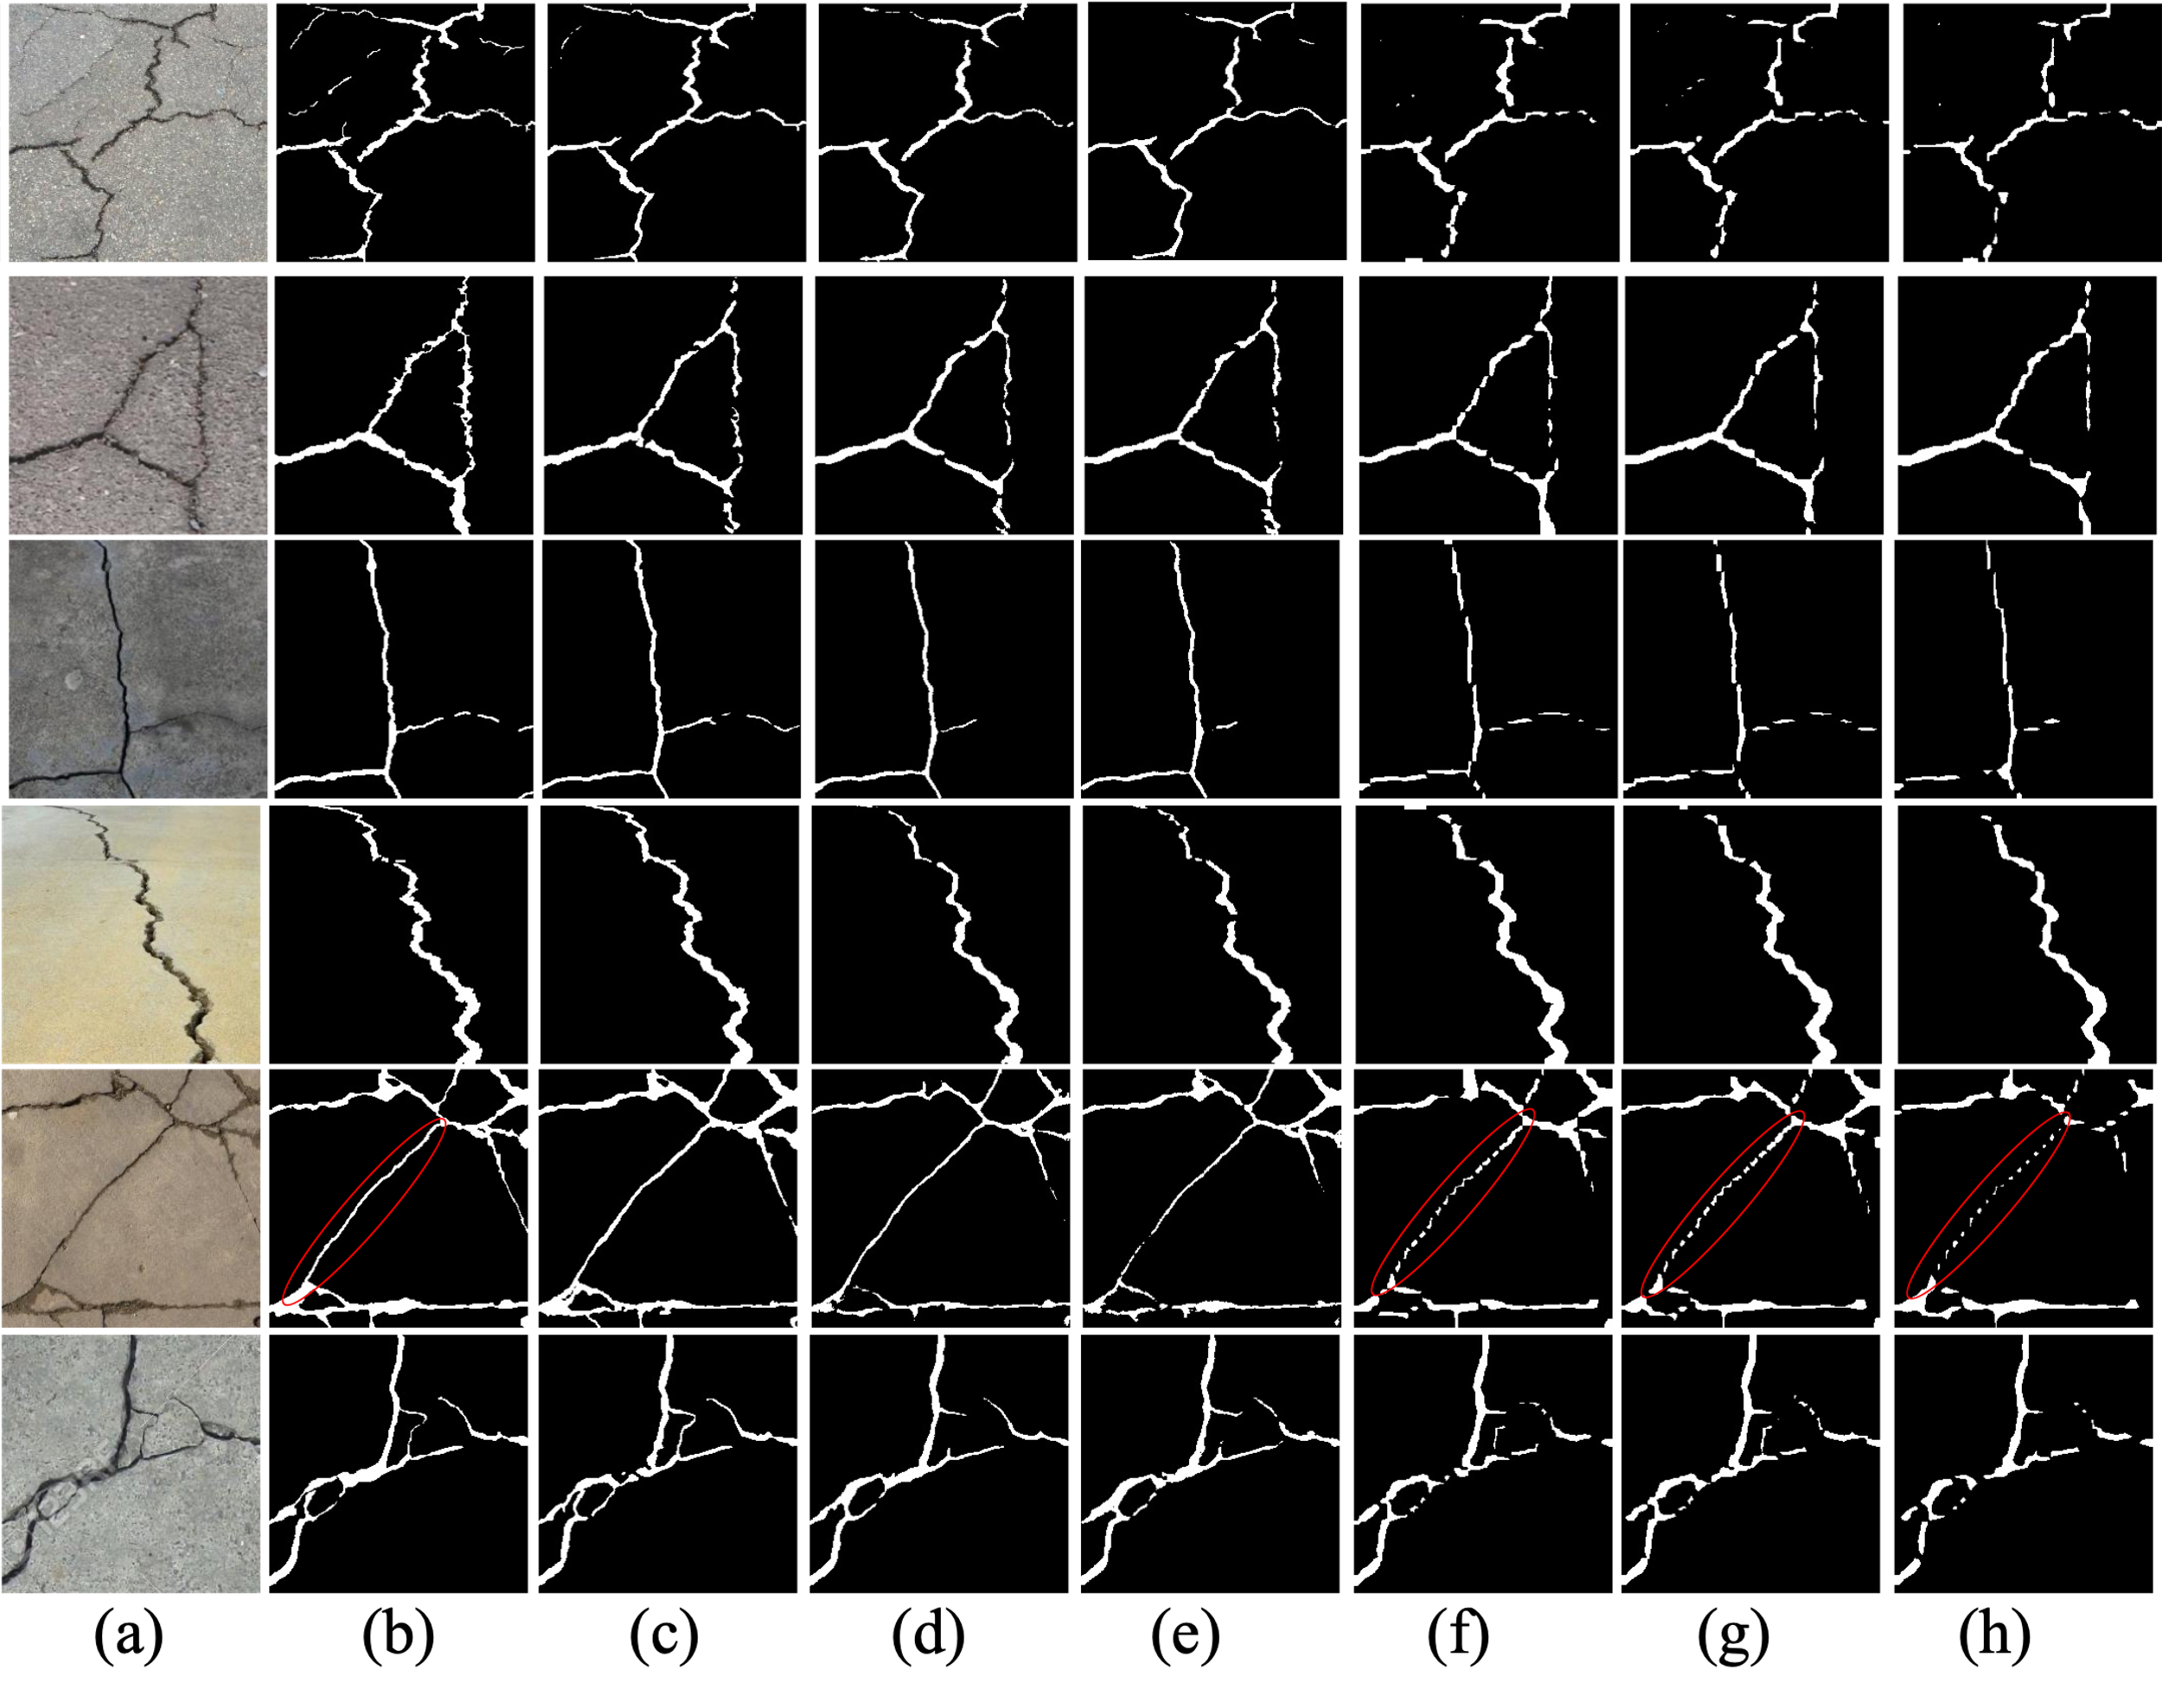
Figure 2. The visualization of detection results of compared methods on DeepCrack Dataset: (a) original image; (b) ground truth; (c) DeepCrack-base; (d) ECSNet; (e) Enet; (f) FCN; (g) DeepLabV3; (h) LRASPP.

As we can see from Figure 2., the results from FCN, DeepLabV3 and LRASPP are intermittent compared to the ground truth especially in the red-circle part. The segmentation images are quite consistent with the accuracy results. It shows that the segmentation results from DeepCrack-base are the closest to the ground truth. But also, the proposed ECSNet performs better than other models in the continuity and accuracy.

3.2 Efficiency evaluation

Figure 3 shows the training time of each model in the training process and the Frames per second (FPS) when using the model to predict. It is noteworthy that the training time each model spend is quite consistent with the FPS. In other words, a model’s complexity determines its efficiency, no matter in training or predicting. And it is interesting to notice that the lightweight models including Enet, LRASPP and ECSNet have averagely lower training time and higher FPS compared to the models with high parameters. The DeepCrack-base consumes the highest time to train its parameters and also has the lowest FPS. The proposed ECSNet has the highest FPS among all the models. The training time of ECSNet, LRASPP and Enet is much lower than other models.
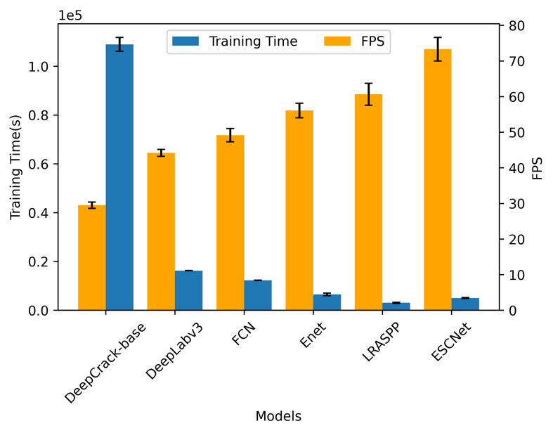
Figure3. The training time and FPS of each model.

3.3 Trade-off between the accuracy and efficiency

In order to give an inspect view to the performance of each method, the accuracy and efficiency are considered together to show the model’s making a trade-off between them. The IoU is used as the main index to represent the model’s performance in accuracy. The IoU is compared with model’s parameters, FPS and training time as shown in Figure 3. Each model is trained and tested three times on the dataset to make the results meaningful in statistic. Therefore, there are three points for each model in Figure 3.

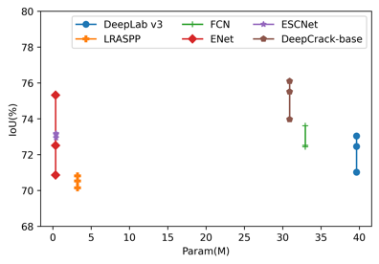 | 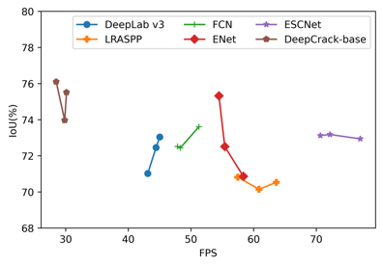 | 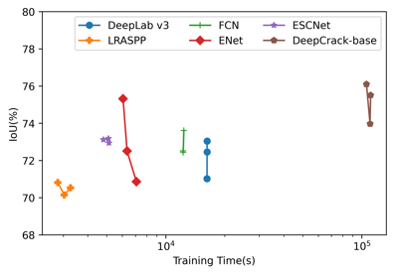
(a) | (b) | (c)

Figure 3. The trade-off between accuracy and efficiency of all compared models: (a) the trade-off between IoU and number of parameters in each model; (b) the trade-off between IoU and FPS of each model; (c) the trade-off between IoU and Training Time of each model.

The parameters contained in a model is an index to show its proper to be deployed in a mobile device. In other words, a light weight model is more reasonable for a mobile usage. Figure 3(a) shows that the Enet and ECSNet has the nearly same parameter amount (0.36M for Enet and 0.41 M for ECSNet) which is much smaller than other models. The average IoU value of Enet and ECSNet is 72.86% and 73.08%, respectively, which is almost the same. However, the variance of IoU from Enet (2.26%) is much higher than ECSNet (0.12%). It means the performance from Enet is not stable enough like ECSNet.

Figure 3(b) shows each method’s performance on IoU and FPS. As mentioned above, the FPS is an index for the method’s real-time performance. The proposed ECSNet get a absolutely higher FPS than other models while its IoU is not lowing when we pay the attention on improving its performance on the information compression and detection speed. Specifically, the segmentation speed for images reaches 73.29 FPS, which is superior to other compared methods. From the test results, we can see that the proposed ECSNet shows great potential in real-time applications.

The training time is also plotted with IoU to show the model’s needing on the computational source to train its original parameters. The results show that the ECSNet only consumes about 5000 seconds to reach a second place in the average IoU value. Compared with other segmentation algorithms, our proposal approach achieves a balance between the amounts of training time and accuracy.

4. Conclusion:

In this work, a Efficiency Crack Segmentation Neural Network (ECSNet) is proposed for real-time pavement crack detection tasks. Some technics are used to reduce the parameters and speed up the information filtering and downsizing. This model is a lightweight real-time semantic segmentation model with high computational efficiency which saves lots of training time. The experiment is conducted to demonstrate the superiority and generalizability of the ECSNet.

Reference:

[1] W. Wang and C. Su, "Deep learning-based real-time crack segmentation for pavement images," KSCE Journal of Civil Engineering, vol. 25, no. 12, pp. 4495-4506, 2021.
[2] X. Sun, Y. Xie, L. Jiang, Y. Cao, and B. Liu, "Dma-net: Deeplab with multi-scale attention for pavement crack segmentation," IEEE Transactions on Intelligent Transportation Systems, vol. 23, no. 10, pp. 18392-18403, 2022.
[3] Z. Qu, C.-Y. Wang, S.-Y. Wang, and F.-R. Ju, "A method of hierarchical feature fusion and connected attention architecture for pavement crack detection," IEEE Transactions on Intelligent Transportation Systems, vol. 23, no. 9, pp. 16038-16047, 2022.
[4] T. Chen et al., "Pavement crack detection and recognition using the architecture of segNet," Journal of Industrial Information Integration, vol. 18, p. 100144, 2020.
[5] F. Liu, J. Liu, and L. Wang, "Deep learning and infrared thermography for asphalt pavement crack severity classification," Automation in Construction, vol. 140, p. 104383, 2022.
[6] A. G. Howard et al., "Mobilenets: Efficient convolutional neural networks for mobile vision applications," arXiv preprint arXiv:1704.04861, 2017.
[7] J. Pang, H. Zhang, H. Zhao, and L. Li, "DcsNet: a real-time deep network for crack segmentation," Signal, Image and Video Processing, pp. 1-9, 2022.
[8] A. Paszke, A. Chaurasia, S. Kim, and E. Culurciello, "Enet: A deep neural network architecture for real-time semantic segmentation," arXiv preprint arXiv:1606.02147, 2016.
[9] L.-C. Chen, G. Papandreou, F. Schroff, and H. Adam, "Rethinking atrous convolution for semantic image segmentation," arXiv preprint arXiv:1706.05587, 2017.
[10] A. Howard et al., "Searching for mobilenetv3," in Proceedings of the IEEE/CVF international conference on computer vision, 2019, pp. 1314-1324.
[11] J. Long, E. Shelhamer, and T. Darrell, "Fully convolutional networks for semantic segmentation," in Proceedings of the IEEE conference on computer vision and pattern recognition, 2015, pp. 3431-3440.
[12] Y. Liu, J. Yao, X. Lu, R. Xie, and L. Li, "DeepCrack: A deep hierarchical feature learning architecture for crack segmentation," Neurocomputing, vol. 338, pp. 139-153, 2019.
[13] T. Kurbiel and S. Khaleghian, "Training of deep neural networks based on distance measures using RMSProp," arXiv preprint arXiv:1708.01911, 2017.
[14] E. Salcedo, M. Jaber, and J. R. Carrión, "A Novel Road Maintenance Prioritisation System Based on Computer Vision and Crowdsourced Reporting," Journal of Sensor and Actuator Networks, vol. 11, no. 1, p. 15, 2022.
[15] T. Zhang, D. Wang, A. Mullins, and Y. Lu, "Integrated APC-GAN and AttuNet Framework for Automated Pavement Crack Pixel-Level Segmentation: A New Solution to Small Training Datasets," IEEE Transactions on Intelligent Transportation Systems, 2023.

